# Name: Mandavi Dubey

Year/Sem: **SE Sem 4**

Div: **A**

# UID No.: 120CP1122B

Roll No.: **23**

* **Experiment No. 5**

**Aim:**   
In this experiment, user will learn To understand the concepts of string in Python programming language. To implement the operations that can be performed in a string.

**Platform:**<http://vlabs.iitb.ac.in/vlabs-dev/labs/python-basics/index.html>

**Code & Output:**

# a) String:

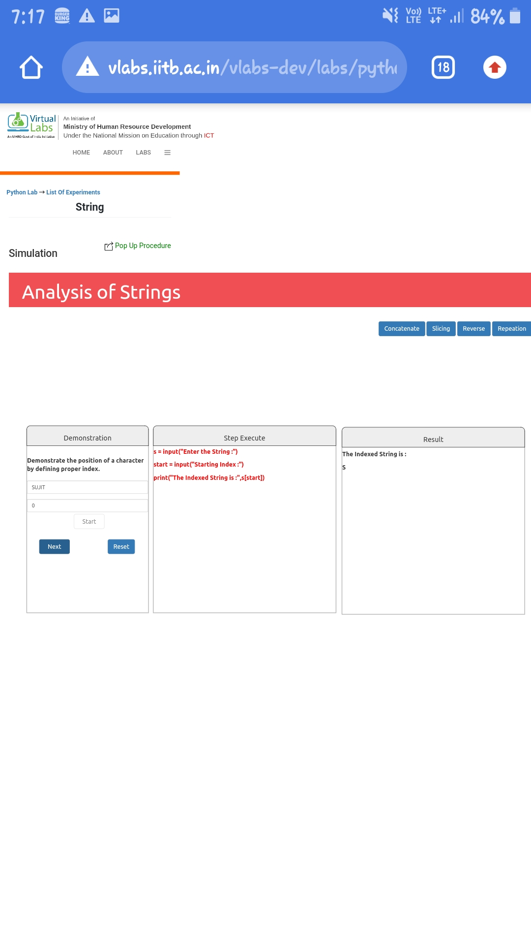

# b) Concatenate:

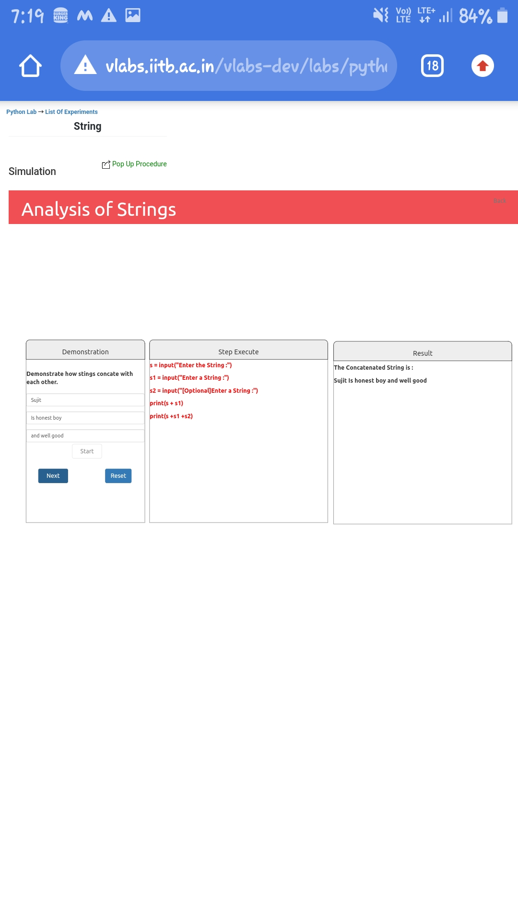

# c) Sliced:

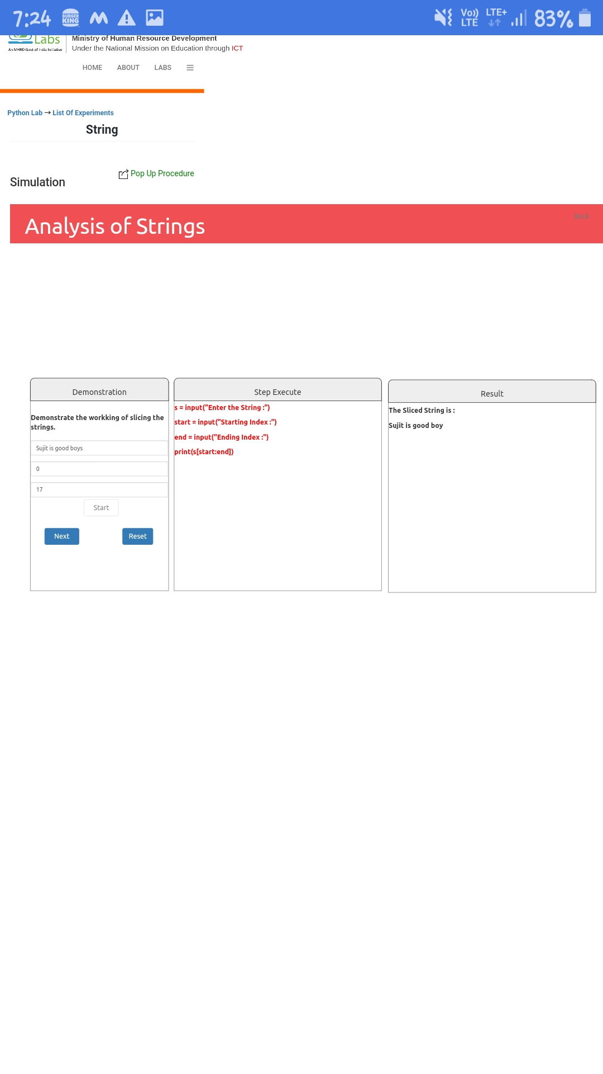

**d) Reversed:**

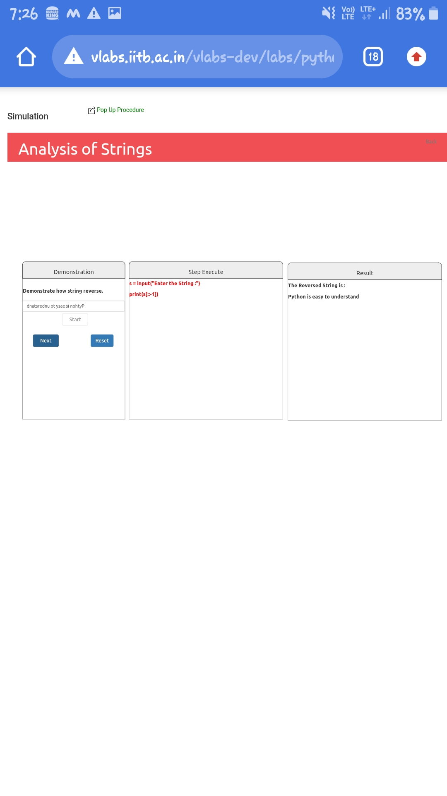

**e) Repeation:**

